

**Table of Contents**

**1. Problem Description 3**

**2. Summary of Individual Analysis 4**

**3. Data pre-processing 6**

3.1. Data Overview 6

3.1.1. Campaigns Data 6

3.1.2. Regular Giving Data 6

3.1.3. Donations Data 6

3.1.4. Campaign Members Data 6

3.1.5. Supporters Postcode Updates 6

3.2. Data Cleaning and Transformation 7

3.2.1. Standardising Dates 7

3.2.2. Grouping Cancellation Reasons 7

3.2.3. Data Reconciliation and Consistency Checks 7

3.2.4. Adjusting Anomalous Gift Dates 8

3.2.5. Identification of Regular Giver Conversion and Data joining 8

3.3. Feature Engineering and Selection 8

3.3.1. Gift Amount Aggregation 8

3.3.2. RG Program Participation Count 8

3.3.3. Donations Beyond RG Program 8

3.3.4. Register Rate vs. Donation Volume Beyond RG Program 9

3.3.5. Contact Channel Availability, Preference 9

3.3.6. Donation Effects Merging 9

3.3.7. Campaign Influence on Regular Giving Conversion 9

3.3.8. Filtering Eligible Donors for RG Conversion Modelling 10

3.4. Postcode-Based Socioeconomic Feature Engineering for Donor Profiling 10

3.4.1. Mapping Postcodes to Lifestyle Segments and Demographic Attributes 10

3.4.2. Calculating Weighted Demographic Proportions 10

3.4.4. Exploratory Analysis and Feature Selection 11

3.5. Contact Information and Reachability Feature 12

3.6. Seasonality in Donation Behavior 13

3.7. Data Transformation and Channel Grouping 14

3.7.1. Association of First Donation Characteristics with Regular Giving Conversion 14

3.7.2. First Donation Consolidation and Channel Preference Adjustment 15

3.7.3. Donor Behaviour Profiling and RFM Scores 15

To further characterise donor behaviours, RFM scores were constructed within a 90-day window following each supporter's first donation. These behavioural dimensions aim to capture both the consistency and depth of supporter engagement, which are critical in identifying potential regular givers: 15

3.7.4. Conversion Trajectory Analysis 17

3.7.5. Donation Frequency Leading to Conversion 17

**4. Modelling, model selection and validation (Machine Learning Pipeline) 18**

4.1. Choice of models 18

4.2. Model Design & Training 19

4.3. Model selection 20

**5. Proposal of the strategic project 21**

5.1. Key issues identification 21

5.2. Rationale for the Recommendation 21

5.3. Strategy Outline 22

5.4. Model exploitation for strategic outreach strategy 22

5.5. How the solution addresses the issue identified 23

5.6. Practical Implementation of the Strategy 24

5.6.1. Competition Analysis 24

5.6.2. Revenue Estimation 24

5.6.3. Cost Estimation 25

5.6.4. Limitations and Assumptions 26

**6. Conclusion 26**

**7. References 27**

# 

# 1. Problem Description

**Background and Business Context**

UNICEF Australia is committed to maximising its impact on vulnerable children across 190 countries, relying on a blend of one-off donations and recurring gifts to support essential education, health, and emergency relief programs. While one-off contributions are crucial, regular donors offer financial stability that is indispensable for long-term organisational impact. Despite this, the majority of supporters donate only once and do not transition to ongoing support, posing a significant challenge to UNICEF’s mission and sustainability.

This issue is not unique to UNICEF. Many nonprofit organisations face similar difficulties converting one-time donors into long-term supporters (Andreoni, 2006). As donor expectations evolve, the fundraising landscape has become increasingly competitive, with individuals seeking greater transparency, personalised communication, and demonstrable impact (Bennett, 2003). Sargeant (2008) analysis underscores that acquiring new donors typically costs two to three times more than retaining existing ones, highlighting the strategic and financial imperative of improving retention.

Recent data further supports the urgency of this issue. Recent research highlights a shrinking donor base despite modest increases in total donations, with competition for donor attention intensifying and digital transformation becoming a key differentiator for successful nonprofits. The Fundraising Effectiveness Project and other sector reports show that while the lifetime value of a donor increases exponentially with retention, the majority of donor losses are concentrated among new and small-dollar donors, underscoring the need for targeted retention strategies (Dataro, 2025). To achieve sustainable growth, UNICEF must understand and address the factors that influence one-off donors to become regular givers and transform this knowledge into strategic retention activities.

**Financial Sustainability**

Regular donors create a predictable revenue stream, reducing UNICEF’s vulnerability to economic shocks and funding volatility. Academic findings demonstrate that even modest improvements in attrition can yield outsized benefits. Sargeant (2008) found that a 10% reduction in attrition could result in a 200% increase in projected donor value, as retained donors are more likely to increase contributions and support multiple initiatives. Barber & Levis (2013) and Guerrini (2025) further confirm that organisations with higher donor retention rates enjoy greater financial stability, better planning capabilities, and reduced acquisition costs.

**Mission Impact**

Higher donor retention enables UNICEF to deliver long-term, sustained programming. Research from the Urban Institute illustrates that organisations with a core base of recurring donors can more reliably plan and scale their mission-driven activities. Repeat donors are not only more likely to increase their giving over time but also to support planned giving, advocacy, and other high-impact engagements (Barber & Levis, 2013; Guerrini, 2025).

**Competitive Advantage Through Predictive Analytics**

To remain competitive, UNICEF must leverage data and digital tools to differentiate its approach. Studies have shown that nonprofits adopting predictive analytics, donor segmentation, and personalised communication techniques see measurable gains (MOAS, 2025). Trust, transparency, and tailored stewardship are critical differentiators, as documented by Ghoorah et al. (2025) and Rolle (2023). These capabilities allow UNICEF to deepen donor relationships and adapt to the expectations of modern supporters.

**Research Aim**

Building on insights generated during the individual exploratory data analysis, this project aims to develop a predictive model that accurately identifies which one-off donors are likely to convert into regular givers. This will enable UNICEF to better prioritise engagement efforts, personalise communications, and improve long-term donor retention.

**Research Questions**

1. What behavioral, demographic, and campaign-level factors most strongly predict donor conversion and retention for UNICEF Australia?
2. How can machine learning models be leveraged to identify high-potential donors and inform targeted marketing strategies?
3. What are the business and social impacts of improving donor retention for UNICEF’s mission?

**Hypotheses**

* Donors with higher engagement, timely recognition, and personalised communication are more likely to convert to regular giving.
* Socio-demographic factors, donation history, and digital engagement metrics significantly influence the likelihood of repeat donations.

**Suitability and Theoretical Grounding**

The proposed analysis is underpinned by donor retention and relationship fundraising theory (Sargeant, 2008), alongside practical insights from industry reports. These frameworks offer a robust basis for understanding donor behaviour and designing ethical, effective interventions. By aligning the predictive system with UNICEF’s mission and operational realities, the project ensures both strategic relevance and implementation feasibility.

**Description of the Model**

In this study, we evaluated four classification models - Decision Tree, Random Forest, Neural Network and XGBoost - to predict the donor conversion. Each model was trained on a historical donor dataset with balanced class weight to mitigate skewness. The model performance was compared using threshold-independent metrics and threshold-dependent macro-averaged F1-score. Those enabled selection based on the strongest precision-recall balance for the target group.

# 2. Summary of Individual Analysis

**Overview of Common EDA Insights Across Members**

All team members conducted comprehensive exploratory data analysis (EDA) to uncover the key characteristics, patterns, and relationships within the UNICEF supporter datasets. The EDA aimed to provide descriptive understanding and actionable insights to inform the group project's variable selection, feature engineering, and modelling strategy. Despite varying analytical approaches and focal points, several consistent findings and complementary insights emerged from the individual tasks.

2.2 Major Data Patterns and Characteristics Identified in Individual Tasks

Report 1: 520552999 Report 2: 530102090 Report 3: 510631839

Report 4: 520625260 Report 5: 520316612

**Donor Behaviour Patterns**

A universally identified pattern was the highly skewed distribution of donor behaviour, where the majority of supporters donated only once, while a minority of donors contributed frequently and with substantially higher cumulative amounts. Reports 3 and 4 applied log transformations to address this skewness and demonstrated that converted donors gave an average of 63 more times than non-converted donors, solidifying donation frequency as the most powerful predictor of conversion across all analyses.

Building on this, Report 5 provided an in-depth RFM (Recency, Frequency, Monetary) segmentation, which confirmed that frequency was a consistently stronger predictor of both regular giving and conversion potential than donation amount alone. Interestingly, while frequent, low-value donors dominated the regular giver segment, some high-value but less frequent donors also exhibited notable regular giving patterns, particularly through annual or installment-based giving structures. This highlights the need to recognise diverse donor archetypes beyond simplistic frequency or amount thresholds.

**Campaign and Channel Insights**

All reports highlighted the critical role of campaign channels and types in influencing conversion rates. Reports 3 and 4 demonstrated that SMS, EDM, and Direct Mail were the most effective solicitation channels, with SMS consistently showing the highest uplift in conversions. Seasonal campaigns, especially those launched in spring and autumn, were identified as peak periods for conversion (Reports 1 and 3).

However, a nuanced insight emerged from Reports 2 and 4, which cautioned against overexposure to campaign activities, showing that excessive outreach frequency can lead to donor fatigue, ultimately lowering conversion likelihood. This complex relationship underscores the importance of balancing campaign volume and timing to maintain supporter engagement without oversaturation.

**Demographics and Geographic Insights**

All reports investigated the impact of supporter demographics and geographic factors on giving behaviour. Income alone was found to have limited predictive power (Reports 2, 3, and 4). However, deeper postcode and MOSAIC segment analyses revealed that certain lower-income or less populous areas (such as SA and TAS) consistently demonstrated above-average conversion rates, likely due to strong community cohesion or targeted local campaigns. Similarly, suburban family segments (MOSAIC Group I) exhibited both strong donation frequency and high conversion rates, as reinforced by Report 5’s segmentation findings. This cross-report observation highlights the need for tailored regional and demographic strategies, avoiding a one-size-fits-all national approach.

**Contactability Insights**

Contactability findings varied across reports. While Reports 1 and 3 initially suggested that donors with more available contact channels were more likely to convert, Reports 2 and 4 challenged this assumption, finding that donors who had opted out of certain channels, particularly mail and phone, actually exhibited higher conversion rates. This was interpreted as a sign of donor fatigue or self-driven commitment, where engaged donors proactively maintain support despite limited channel availability, challenging traditional assumptions about multichannel engagement being inherently positive.

**Product Loyalty and Donor Migration Insights**

Report 5 uniquely contributed insights into product-level behaviours, revealing high product loyalty among regular givers, particularly within the Global Parent program. The report observed that donors rarely migrated across products, and most conversions happened within the same product they initially supported. This finding suggests that conversion into regular giving is often self-motivated rather than actively driven by UNICEF campaigns, pointing towards opportunities to leverage historically successful programs like Global Parent as focal points for conversion strategies, while also highlighting the need for improved cross-product engagement strategies.

# 3. Data pre-processing

## 3.1. Data Overview

The analysis utilised comprehensive UNICEF datasets, including Campaigns, Regular Giving, Donations, Campaign Members and Supporters, to understand supporter behaviours and characteristics that drive regular giving conversion. Each dataset was loaded into chunk pandas Data Frames, ensuring efficient handling and manipulation of large data volumes.

### 3.1.1. Campaigns Data

The Campaigns dataset contains details of 21,943 campaigns across ten variables, including CampaignID, Type, Sub_Type, Content_Thematic_Area, Content_Focus, Solicitation_Channel, Appeal_Season, Activity, and Start_Date. While core attributes such as CampaignID, Type, Sub_Type, and Appeal_Season were fully populated, legacy fields presented substantial missing data, particularly Content_Thematic_Area (missing in 87% of records), Solicitation_Channel (44% missing), and ParentID (42% missing). Minimal missing data (<1%) were observed in Content_Focus, Start_Date, and Activity fields. Effective data imputation and cleaning were crucial to leveraging these campaign attributes in subsequent analyses.

### 3.1.2. Regular Giving Data

The Regular Giving dataset (superstar) comprises 158,301 rows and 14 attributes detailing supporters' ongoing donation products, acquisition channels, and subscription start and cancellation dates, along with cancellation reasons. Data assessment identified missing values in 15% of the Cancellation_Date and 16% in the Cancel_Reason fields. Significant effort was required to logically group cancellation reasons, impute missing cancellation dates for active donors, and rectify discrepancies associated with RGIDs, thereby maintaining data integrity for accurate analysis.

### 3.1.3. Donations Data

The Donations dataset includes 6,114,649 transactional records across eight attributes, namely SupporterID, CampaignID, Gift_Date, Gift_Amount, Payment_Type, Donation_Channel, and RGID. Core transactional fields are fully populated, ensuring robust transaction-level analysis. Nevertheless, RGID was missing in 19% of one-time donation records, and Donation_Channel information was absent in roughly 10% of cases, which required detailed reconciliation and careful consideration to ensure data consistency and accuracy. To further prepare the dataset for robust predictive analysis, monetary values underwent log transformation to normalize distributions and mitigate the impact of outliers, enhancing analytical stability and model interpretability.

### 3.1.4. Campaign Members Data

The Campaign Members dataset records 4,950,402 interactions between supporters and specific campaigns, captured within four fully populated and duplicate-free fields: MemberID, CampaignID, SupporterID, and MemberCreatedDate. This robust dataset provided precise temporal mapping of supporter interactions, essential for accurate analysis of campaign effectiveness.

### 3.1.5. Supporters Postcode Updates

The Supporters dataset consists of 661,292 records with 18 variables, encompassing unique SupporterIDs, donor types, demographic details, and contact preference indicators. While key attributes like SupporterID and contact flags were completely populated, the dataset contained significant gaps in several demographic fields. Specifically, Age_Bucket had a high missing rate of 90%, and mailing address details (State, Postcode, City, Country) were missing in 61% of records. Additionally, partial incompleteness (23%) was noted in the First_Gift_Date and Last_Gift_Date fields, necessitating meticulous handling to preserve analytical integrity.

To address geographic data accuracy issues, an external dataset (SupporterPostcodeUpdate.csv) was integrated to update and enhance postcode information. Initially, placeholder values ('Null', 0) were systematically standardised to missing values (NaN), ensuring consistency for accurate data merging. Subsequently, original postcode fields in the Supporters dataset were replaced through precise mapping using unique SupporterIDs from the external dataset. This careful approach significantly improved the accuracy and completeness of geographic information, facilitating reliable demographic segmentation and more insightful donor behavior analysis in subsequent analytical steps.

## 3.2. Data Cleaning and Transformation

### 3.2.1. Standardising Dates

All date-related columns (Start_Date, Gift_Date, MemberCreatedDate, Date_Established, Cancellation_Date) across datasets were standardized into a consistent datetime format. Missing campaign start dates were methodically filled using corresponding earliest gift dates from Donations or earliest member interaction dates from Campaign Members, ensuring logical and temporal accuracy. Additionally, current dates were assigned to active subscriptions missing cancellation dates, enabling calculation of accurate donation durations.

### 3.2.2. Grouping Cancellation Reasons

To improve the clarity and interpretability of donor cancellation data, detailed cancellation reasons were systematically grouped into broader, meaningful categories:

* **Financial Difficulty:** Including terms indicating affordability and economic hardship.
* **Banking & Payment Issues:** Covering specific transaction-related difficulties like bank card errors.
* **No Reason/No Response:** Cases lacking explicit cancellation reasoning.
* **Life Circumstances/External Factors:** Situations such as moving overseas or donor deaths.
* **Admin/Sign-up Issues:** Errors during sign-up processes or administrative mishaps.
* **Dissatisfaction/Complaints:** Reasons explicitly indicating dissatisfaction with the product or organization.
* **Other/Miscellaneous:** Catch-all category for unclassified cancellation reasons.

### 3.2.3. Data Reconciliation and Consistency Checks

A rigorous and systematic approach was taken to address inconsistencies between the Donations and Regular Giving (superstar) datasets, particularly regarding missing or mismatched RGIDs. Initial identification involved extracting unique RG participants from the Donations data and matching them against the existing Regular Giving records. Donors who existed in Donations with valid RGIDs but lacked corresponding records in the Regular Giving dataset, and vice versa, were carefully isolated to rectify this gap.

For some features, missing data is filled using information from other tables. However, when filling unmatched records without corresponding entries, assumptions and logical reasoning are used to "reconstruct" the missing data.

For example, in cases where donors have valid RGIDs but the corresponding **SupporterID–RGID** pair is not recorded in the **donation table**, certain columns—such as *Donation Channel*, *Gift Amount*, and *DonationID*—are also missing in the **Regular Giving** table.

This issue is addressed under the following assumptions:

* Regular Giving (RG) donations start on the first date of the program,
* Donations are made on time when due,
* All RG donations are made through the **Recurring Run** channel.

Based on these assumptions, the number of gifts is estimated using the donation duration and frequency associated with each RGID. The total gift amount is then calculated accordingly. Finally, unique DonationIDs are randomly generated in the same format as existing entries, with a loop check to ensure no duplication across the dataset.

### 3.2.4. Adjusting Anomalous Gift Dates

Certain donation records contained unrealistic initial gift dates (e.g., dates before UNICEF's existence). These were adjusted using subsequent valid donation timestamps, maintaining temporal credibility and data integrity.

### 3.2.5. Identification of Regular Giver Conversion and Data joining

To accurately identify and analyse regular giver conversion patterns, a structured and thorough approach was employed. This involved precisely pinpointing the first donation date (Gift_Date) of each supporter from the Donations dataset. These initial donation dates served as a foundational timeline against which subsequent subscription activities could be compared, facilitating an accurate classification of donors who converted from one-off to regular giving.

Further rigorous filtering criteria were applied to define "real" regular givers, establishing a threshold for meaningful participation in the regular giving program. Donors were classified as genuine regular givers only if they participated in the program for at least 60 days, a period long enough for them to make at least two donations under typical monthly giving schedules. This condition effectively excluded transient donors with short-lived subscriptions, whose limited engagement could distort conversion metrics. Additionally, donation amounts were capped at a realistic threshold (below $3,000) to avoid outliers that might compromise analysis integrity.

After applying these conditions, the number of genuinely engaged regular supporters was clearly quantified, resulting in approximately 127,052 valid regular giving participants and around 24,128 currently active donors. These figures provided a robust and realistic foundation for subsequent analytical modelling and targeted interventions.

To enhance analytical depth, the study calculated the number of donations each supporter made before joining the RG program. This was done by first identifying each supporter's first RG subscription date (Date_Established) and comparing it with their full donation history. Specifically, donations with a Gift_Date earlier than the supporter’s Date_Established were counted to determine their pre-conversion donations number. These calculations applied only to those who converted into RG. The data was grouped by SupporterID, and left joins were used strategically to retain full records and avoid loss of donation history. This metric offered valuable insights into donor behaviour and generosity prior to RG commitment, informing retention and conversion strategies.

## 3.3. Feature Engineering and Selection

### 3.3.1. Gift Amount Aggregation

The initial feature computed is the total Gift_Amount per SupporterID, aggregated using the donations table. This continuous variable is essential as it encapsulates a donor’s overall monetary engagement and generosity. Donors contributing larger cumulative amounts may be more inclined to convert to regular giving due to deeper commitment or financial capacity.

### 3.3.2. RG Program Participation Count

The number of RG programs each donor has participated in is calculated next, with explicit inclusion of non-RG donors (counted as zero). This inclusion of zero-inflated data is methodologically sound as it preserves the contrast between converters and non-converters, critical for binary classification tasks.

### 3.3.3. Donations Beyond RG Program

The donations_beyond feature measures how many times a donor gave outside of RG contexts. It serves as a proxy for donor consistency and breadth of engagement. Donors who continue giving despite not being in an RG program may be strong prospects for conversion.

### 3.3.4. Register Rate vs. Donation Volume Beyond RG Program

A correlation analysis is performed between the number of donations made beyond RG program and RG register rates, restricted to donations ≤50 to reduce skew. A clear positive trend is shown, where higher donation frequency correlates with greater likelihood of conversion.

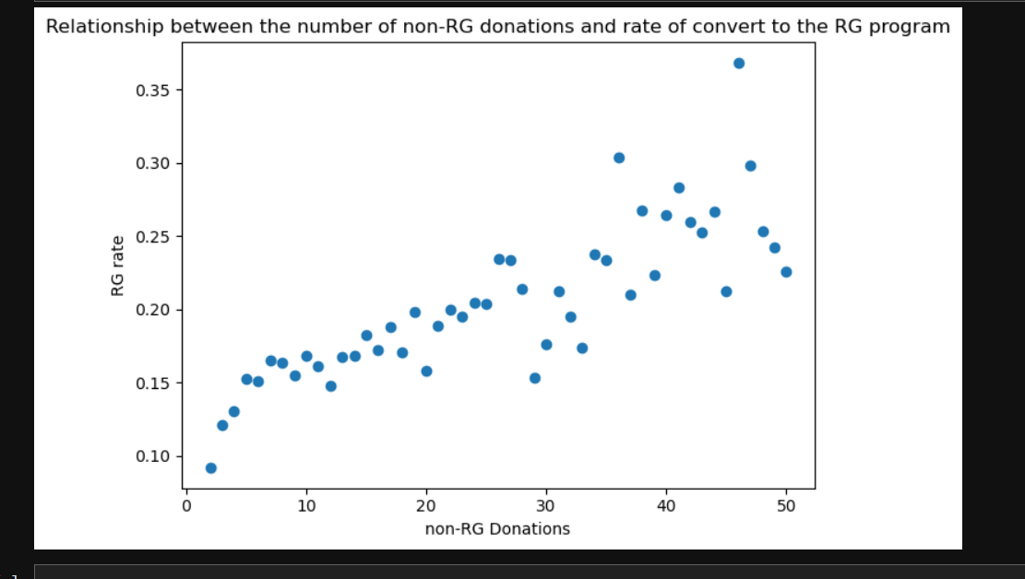

Figure 1. RG rate for non-RG Donations

### 3.3.5. Contact Channel Availability, Preference

The avail_index quantifies each donor’s reachable communication channels by summing binary indicators for whether they provided a home phone, mobile number, email, or work phone. A higher score suggests greater accessibility for UNICEF outreach. In contrast, the prefer_index tallies the number of communication methods a donor has opted out of (DoNotMail, DoNotEmail, DoNotPhone, DoNotSMS), serving as a proxy for their willingness to be contacted, which is an important signal for campaign strategy.

### 3.3.6. Donation Effects Merging

This feature engineering step builds a multidimensional donor profile by combining key behavioural features created above, such as contact accessibility, communication preferences, engagement history, and financial activity. These integrated features are essential for accurately predicting a donor’s likelihood of converting to an RG.

The register variable is a binary indicator that flags whether the donor eventually converted into an RG supporter, and thus serves as the dependent variable in predictive modelling. Duration measures the total number of days the donor remained active in the RG program, offering insight into long-term commitment. Amount aggregates the total donation value across all donations, capturing financial capacity and philanthropic intent. Finally, Pre_donation reflects the number of one-time donations made before entering the RG program, which helps distinguish between donors who are acquirers rather than a converter and those who convert quickly.

### 3.3.7. Campaign Influence on Regular Giving Conversion

During the analysis, it was observed that certain campaign types are highly effective at acquiring and converting donors to Regular Giving (RG). This led to the hypothesis that some campaigns are specifically designed to acquire RG donors.

To test this hypothesis, we identified the first RG campaigns for converters and found that over 90% of them overlapped with the first campaigns of RG acquirers. In contrast, among non-converters, only about 2% of their participated campaigns overlapped with either the first campaign of RG acquirers or the first RG campaign of converters.

To evaluate the statistical significance of this finding, a contingency table was constructed linking campaign IDs to conversion outcomes. We retained only campaigns with at least 30 participants to ensure statistical reliability. A chi-square test revealed a highly significant association (*p* < 0.00001), suggesting that certain campaigns are indeed tailored to acquire and convert donors.

By identifying campaigns specifically designed to acquire and convert RG donors, we can avoid data leakage. Additionally, this insight provides a basis for filtering out ineligible observations in subsequent conversion analyses.

### 3.3.8. Filtering Eligible Donors for RG Conversion Modelling

This data preparation step filters the dataset to retain only relevant donor groups for training a predictive model,specifically, those who either converted to RG after making at least one one-time donation (Pre_donation > 0 and RGID ≥ 1), or those who made one-time donations but were never enrolled in an RG program (RGID = 0). Donors with no recorded donation history (DonationID = 0) are excluded to avoid introducing noise.

Additionally, we remove donors whose last donation occurred over 100 days before the first-ever RG program was established, as these donors likely disengaged before the RG offering existed. We also exclude donors who joined UNICEF recently (within the last 80 days), since the median conversion period after the first gift is approximately 90 days. Including these supporters would not allow sufficient time for conversion behaviour to manifest, potentially skewing the analysis.

We also remove donors who were acquired via RG campaigns, which were identified earlier, but failed to convert and were never recontacted by UNICEF (or contacted fewer than two times), making it impossible to determine if they might have converted under different circumstances.

After removing these ineligible entries, the final dataset (to_train) includes only donors that are converters or non-converters who we can reasonably assume that they were at least once attempted by UNICEF to convert, , providing a clean, focused sample for training classification models.

## 3.4. Postcode-Based Socioeconomic Feature Engineering for Donor Profiling

To better understand donor behaviour and enhance model performance, postcode data was transformed into a set of interpretable socioeconomic features. This transformation involved leveraging lifestyle segmentation groupings and demographic characteristics associated with each postcode cluster.

### 3.4.1. Mapping Postcodes to Lifestyle Segments and Demographic Attributes

Each postcode was mapped to a specific lifestyle group based on a classification schema that segments households into categories such as “First Class Life” (affluent middle-aged families), “True Grit” (blue-collar workers), and “Graceful Ageing” (older retirees with low income). Each group was annotated with binary demographic indicators describing the typical household, including:

* **Income level**: High_Income, Low_Income
* **Age group**: Young, Old
* **Family structure**: Children, School_aged, Couple

### 3.4.2. Calculating Weighted Demographic Proportions

To reflect the demographic makeup of each postcode area, the demographic indicators were weighted by the local population size. This was achieved using matrix multiplication: the one-hot encoded postcode matrix was dot-multiplied with the demographic mapping. The resulting postcode_grouped matrix provided the total number of residents in each postcode that fit each demographic attribute. Normalising this by total postcode population yielded a proportion-based profile (e.g., 68% high income, 45% young adults, 12% of households have school-aged children).

### 3.4.4. Exploratory Analysis and Feature Selection

To assess how postcode-level demographics relate to donor behavior (specifically, conversion to regular giving), multiple statistical and visual techniques were applied:

* **Line plots**: Binned plots showing the relationship between demographic proportions (e.g., % high-income residents) and the regular giving rate revealed mild trends. High-income and young population proportions were positively associated with conversion rates, while low-income and school-aged populations showed negative associations.

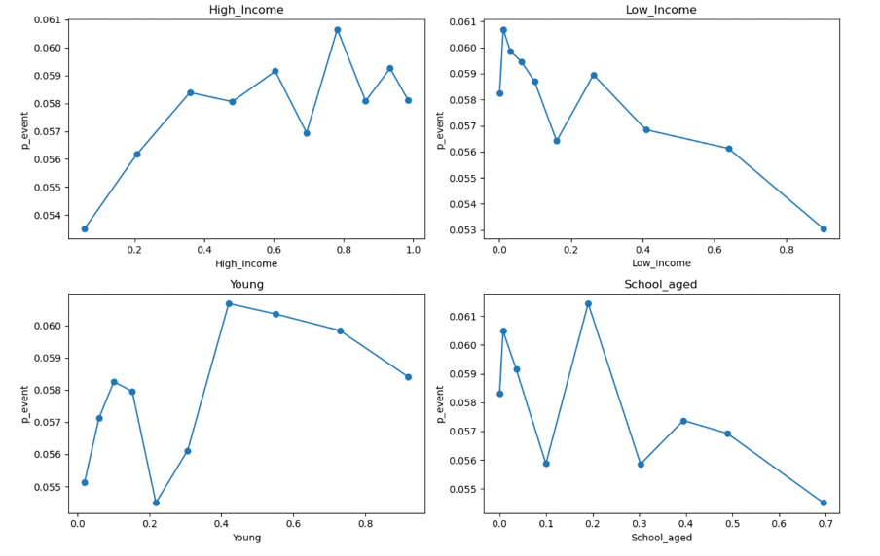

Figure 2. Line plots for Demographic Proportions

* **Point-biserial correlations**: These tested linear associations between demographic ratios and binary conversion outcomes. Significant positive correlations were found for High_Income and Young, while Low_Income and School_aged were negatively correlated with regular giving.

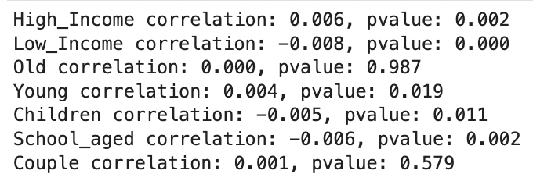

Figure 3. Correlations Outcomes

* **Crosstab analysis**: Donors were grouped into income, age, and household type categories. Conversion rates were then calculated across groups, confirming the earlier trends. Middle-income donors had the highest conversion rate (6%), slightly ahead of high-income (5.88%), with low-income donors trailing at 5.48%. Younger donors (under 35) converted most often (5.98%), followed by older (5.78%) and middle-aged groups (5.62%). Postcodes with school-aged children showed the lowest conversion (5.51%), while single (5.7%), child-free (5.83%) and couple-dominant areas (5.81%) performed better. These findings suggest that engagement is strongest among younger, middle-income, and child-free donors—likely due to greater flexibility and value-driven motivations.

## 3.5. Contact Information and Reachability Feature

To better understand the role of contact accessibility in donor behavior, we engineered a composite feature called **Contactability Index**, which quantifies how reachable each donor is across various communication channels—email, SMS, phone, and mail. This helps assess whether multi-channel contact potential influences conversion to RG.

We began by deriving four binary indicators based on donor consent and available contact fields:

* **Email_Reach** is set to 1 if the donor has a valid email and has not opted out of email or general contact.
* **SMS_Reach** is set to 1 if the donor has a mobile phone and has not opted out of SMS or general contact.
* **Phone_Reach** is set to 1 if the donor has any phone (home, mobile, or work), has not opted out of phone communication, and has not opted out of contact entirely.
* **Mail_Reach** is set to 1 if the donor has not opted out of mail and general contact.

These four indicators are summed to compute the final **Contactability Index**, ranging from 0 to 4, where a higher score implies a donor is reachable through more communication methods.

The relevance of this feature was assessed by visualising the relationship between contact ability and donation behaviour. A negative correlation emerged between the number of donations and the average contact ability index—suggesting that donors with broader contact reach tend to donate earlier or are more responsive upfront.

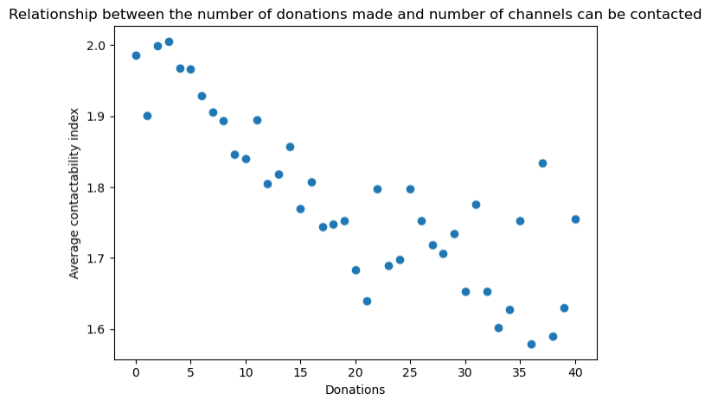

Figure 4. Average Contactibility Index

We further plotted the event rate (probability of conversion to RG) against the contact ability index with a 95% confidence interval, revealing a non-linear relationship. Donors who had no reachable contact channels (score = 0) showed the highest probability of conversion, possibly indicating organic or passive conversion through self-motivation or prior offline engagement. On the other hand, those with only one contact method had the lowest conversion probability, suggesting that limited contact options may be insufficient to build trust or familiarity. However, the conversion likelihood increased steadily for donors who were contactable through two or more channels, plateauing slightly after three. This finding implies that multichannel engagement—rather than relying on a single method—is more effective in encouraging regular giving.

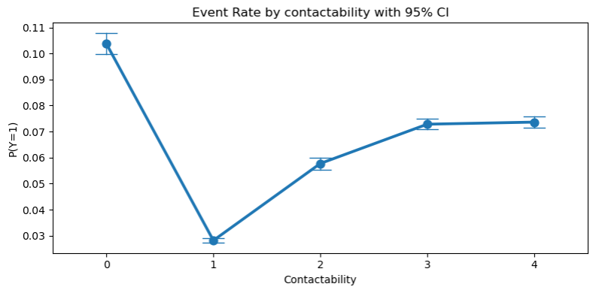

Figure 5. Event Rate by Contactability with 95% CI

## 

## 3.6. Seasonality in Donation Behavior

To explore if the **month of donation** affects whether a donor becomes a regular giver, we looked at the most common month each donor made their donation. We then compared these months between two groups: **converters** (those who became regular donors) and **non-converters** (those who didn’t).

We calculated the proportion of donors in each group who made their most common donation in each month and visualized the results using side-by-side bar charts. The patterns showed that **both groups donated the most in June**, followed by **November and December**. This suggests that certain times of the year—possibly due to tax deadlines (end of financial year in June) or the holiday season—encourage more donations across the board.

However, the slight differences between converters and non-converters during other months may hint at seasonal factors influencing who is more likely to commit to regular giving. For example, donors who converted were slightly more spread across the year, while non-converters showed more concentration in specific months like December. This insight can help UNICEF better plan when to run campaigns that aim to convert one-time donors into regular givers.

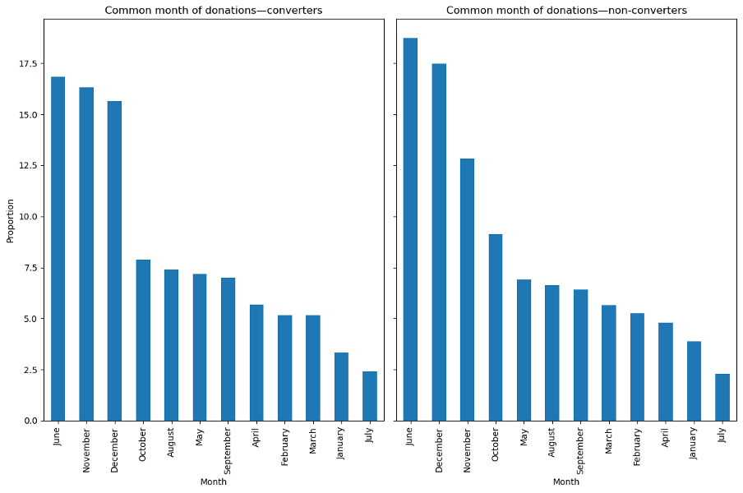

Figure 6. Seasonality in Donation Behavior

## 3.7. Data Transformation and Channel Grouping

To facilitate analysis and improve interpretability, solicitation channels and campaigns were consolidated into broader categories based on their characteristics and usage context. This grouping approach aligns with best practices in campaign effectiveness evaluation, allowing for clearer insights into channel performance.

* **Solicitation channels** were classified into six groups:
  + Mass Media
  + Telemarketing
  + In-Person
  + Direct Mail
  + Digital/Online
  + Other/Passive

Similarly, **campaign activities** and **sub-types** were grouped into higher-level categories such as Signature Event, Standard Appeal, Corporate/Partner, Gifts, Engagement/Stewardship, and Miscellaneous.

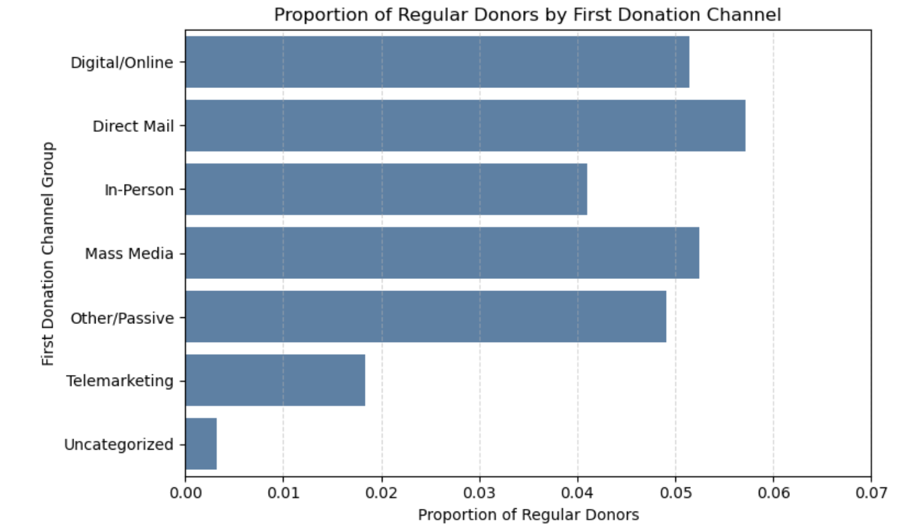

Figure 7. Distribution of first donation channels across the sample

### 3.7.1. Association of First Donation Characteristics with Regular Giving Conversion

A chi-squared test and Cramer’s V were performed to evaluate the association between first donation characteristics (channel, season, activity, sub-type) and the likelihood of a donor becoming a regular giver.

* The strength of association between **first donation channel group and regular giving conversion** was found to be weak, with a **Cramer's V of 0.064**.
* **First donation season** also showed a weak association (**Cramer's V = 0.035**), with conversions being slightly more likely when first donations occurred in Autumn and Spring.
* Regarding the **first donation sub-type**, the association remained minimal (**Cramer's V = 0.039**), with donations under 'Appeal' showing a marginally higher conversion rate.

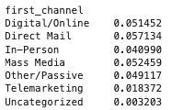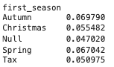

Figure 9. Cramer's V results for each characteristic

### 3.7.2. First Donation Consolidation and Channel Preference Adjustment

Recognising that donors might make multiple donations across different channels on the same day, an aggregation was applied. This process:

* Summed all donations made on the first day.
* Assigned the most common or highest-contributing donation channel and payment method.
* Excluded any donations under the RG program to ensure a clean focus on converter journeys only.  
  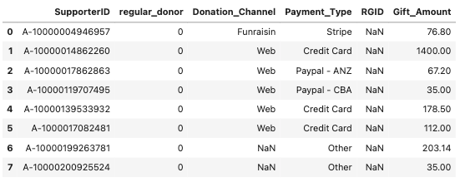

Figure 10. First donation sample after collapsing to supporter level

### 3.7.3. Donor Behaviour Profiling and RFM Scores

#### To further characterise donor behaviours, **RFM scores** were constructed within a 90-day window following each supporter's first donation. These behavioural dimensions aim to capture both the consistency and depth of supporter engagement, which are critical in identifying potential regular givers:

* **R_score**: Number of days between the first donation and the start of the campaign (lower values reflect higher recency).
* **M_score**: Total log-transformed donation amount accumulated within the 90-day window.
* **F_score**: Number of donations made during that window.
* **R_mean**: Average number of days between donations — introduced as a proxy to simultaneously capture recency and frequency dynamics.

The inclusion of **R_mean** is particularly insightful. While R_score alone reflects proximity to the campaign start, R_mean integrates a supporter’s **donation cadence** — a key behavioural signal. Donors with a high **R-mean** value indicate multiple donations and more “recent” giving behavior. Recency has been shown to be a strong predictor of a donor’s likelihood to convert. However, due to the lack of detailed information and documentation on how and when UNICEF contacts and converts donors, creating a specific snapshot time point can potentially introduce both bias and data leakage into the analysis.

To address this, **R-mean** is implemented under the assumption that UNICEF waits a certain period after a donor’s first gift to observe their behavior. Among donors who give multiple times, a higher R-mean is associated with a higher conversion rate. This approach avoids data leakage by setting a fixed observation window after the first donation, and reduces bias by giving each donor the same duration to be observed.

A 90-day window is chosen in this case because the median time to conversion after a donor’s first gift is 90 days. However, earlier visualizations indicate two important patterns:

1. Most converters convert after their first gift.
2. Most converters convert within 60 days of their most recent donation.

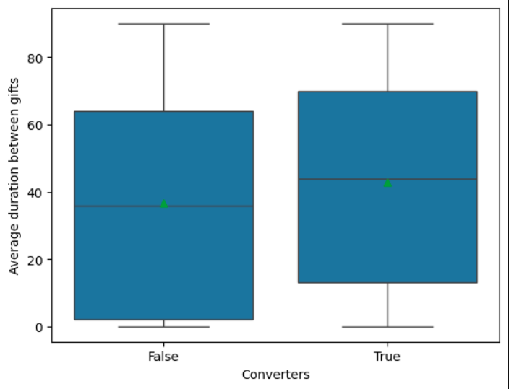

Figure 11. Average duration between gifts

The idea of R-mean within a fixed window is not a true standalone predictor. Instead, it is a feature that helps improve model accuracy with minimal risk of data leakage or bias while supporting UNICEF in understanding the critical role of recency in donor conversion.

Finally, M_score is included despite the log amount of the first donation also being part of the feature set. This feature remains because our selected model performs well even in the presence of collinearity, and the M_score itself helps distinguish between enthusiastic donors and wealthy enthusiastic donors.

**Commentary** As noted in reflection, R_mean is a novel addition that helps bridge timing and behavioural intent. While we cannot definitively verify whether a donor was contacted before converting (due to data limitations), statistically, those who convert often donate multiple times within the assumed 90-day conversion window. This supports the hypothesis that frequent, well-timed giving increases the likelihood of conversion — either due to proactive engagement or inherent donor motivation. Importantly, R_mean avoids data leakage by not directly referencing future behaviour while still capturing important temporal dynamics.

These findings justify the inclusion of **R_mean as a model feature** and reinforce the importance of recognising donation tempo — not just frequency — as a behavioural predictor of conversion. This also opens new strategic avenues: rather than targeting only high-frequency donors, UNICEF could consider supporters who donate **closely spaced small gifts**, as they may be displaying early signals of recurring intent.

### 3.7.4. Conversion Trajectory Analysis

A heatmap was plotted to visualise how the number of gifts evolves as donors approach the moment of conversion:

* Converters with **3+ pre-conversion donations exhibited a much more compressed giving pattern**, with most gifts clustering closer to the conversion date.
* Conversely, those with fewer donations exhibited a more scattered pattern.

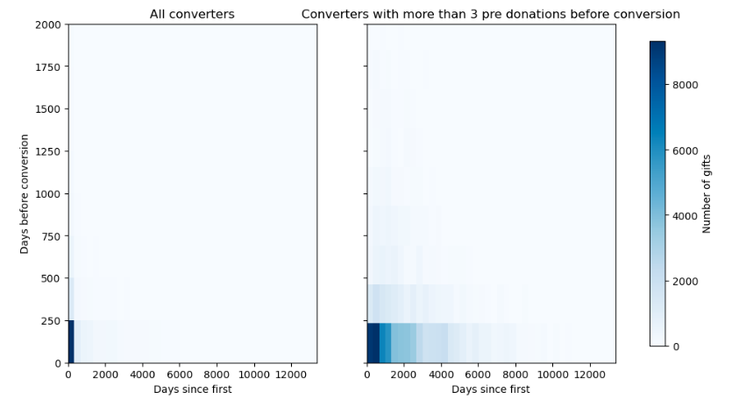

Figure 12. Day Before Conversion Heatmap

This pattern suggests a **behavioural acceleration effect** among highly engaged supporters, which could serve as a signal for prioritising conversion outreach and may also signal that in-time contact help boost the rate of conversion for potential converters.

### 3.7.5. Donation Frequency Leading to Conversion

Finally, the average gifts per donor was plotted in 30-day bins up to 365 days before conversion.  
Findings indicated:

* Most donors make their last donation within 90 days prior to conversion. Beyond this point, it could indicate either a lower likelihood of conversion or a potential lack of follow-up engagement from UNICEF.

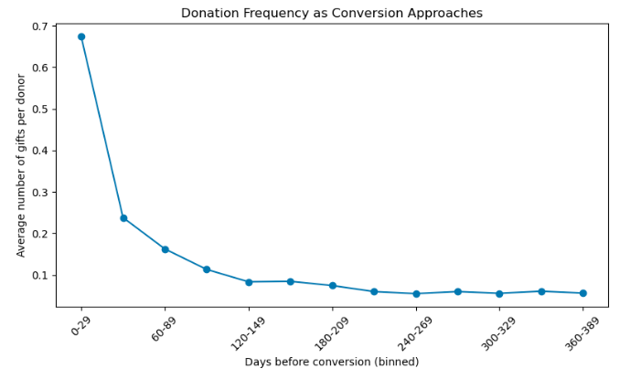

Figure 13. Donation Frequency as Conversion Approaches

# 4. Modelling, model selection and validation (Machine Learning Pipeline)

## 4.1. Choice of models

The dataset presents several modelling challenges.

**Imbalanced target classes:** Only a small proportion of donors converted to regular givers, making the dataset highly imbalanced. This imbalance risks models being biased toward the dominant non-converter class, making accuracy misleading.

**Skewed distribution & Presence of outliers**: Several predictor variables including *Gift_Amount* and *Donations Beyond RG Program*display strong positive skew, affecting model stability. Additionally, extreme values were identified in *Gift_Amount, Total_donation*. While log transformation and upper cap thresholds (e.g., <$3,000 for donations) were applied to reduce distortion during training, these issues remain carefully considered throughout the modelling process.

**Non-linear relationships**: Likelihood of conversion to regular giving is driven by non-linear patterns and interactions among variables.

**Decision Tree**

The decision tree was chosen for its effectiveness in capturing non-linear relationships. It also handles binary variables well. However, it is highly prone to overfitting, particularly in the presence of significant outliers, as discussed above. Despite this limitation, it was selected as the base model due to its simplicity and high interpretability (Räz, 2024)

**Random Forest**

Random Forest builds on the decision tree by combining multiple trees through bagging, reducing overfitting and improving generalisation. This makes it more robust to the dataset’s noise, skewness and outliers. It also handles class imbalance better by allowing class weights to be adjusted, ensuring the minority class (converters) is properly learned. On the downside, it is computationally intensive and time-consuming to train, especially with large datasets and it sacrifices interpretability compared to single decision trees. (Breiman, 2001).

**Neural Network**

Neural networks were implemented due to their ability to capture intricate and non-linear data patterns. However, similar to random forests, they are computationally demanding and suffer from interpretability issues due to the low transparency in their decision-making processes (Ribeiro et al., 2024). Without proper regularisation, neural networks are also susceptible to overfitting.

**XG Boosting**

XG boosting was selected for its gradient boosting mechanism, which sequentially builds decision trees that focus on correcting errors made by previous trees. This iterative process improves classification performance, particularly on misclassified minority class entries, which is ideal for the imbalanced donor conversion data.

## 4.2. Model Design & Training

The dataset was split into training and testing sets using an 80/20 ratio to simulate generalisation. A 5-fold cross-validation was applied on the train data to evaluate model performance across various parameter combinations, ensuring optimal parameter tuning for each model. Due to the severe class imbalance, where the positive class (converted donors) is significantly underrepresented, ROC AUC can present an overly optimistic evaluation of model performance, as it includes true negatives, which are abundant. In contrast, Precision-Recall AUC (PR AUC) concentrates on the minority class by assessing precision and recall, making it more appropriate in the imbalanced context. As a result, PR AUC was used as the primary scoring metric during cross-validation to guide hyperparameter tuning.

**Decision Tree**

To determine the optimal depth, cross validation was performed across depth values ranging from 4 to 20. For each candidate max_depth, the model was trained and evaluated using average precision as the scoring metric. The best-performing depth, max_depth = 17, was selected for its ability to maximise predictive performance while avoiding overfitting. Additionally, class_weight='balanced' was applied to address the skewed class distribution, enabling the model to place greater emphasis on correctly identifying the minority class.

The feature importance analysis revealed that **contact_index** was the most influential predictor in the decision tree, contributing nearly 38% to the model's decisions. This suggests that responsiveness is a strong indicator of a donor's likelihood to convert. Other significant features included **Area_Score** and **R_Score**, reflecting demographic or behavioural clustering that may correlate with giving patterns.

**Random Forests**

A random forest model was developed to predict donor conversion, with hyperparameters tuned via out-of-bag (OOB) validation and early stopping, which is the trade-off between time and accuracy. The model’s performance was assessed using precision–recall area under the curve (PR AUC) and ROC AUC.

A grid search was conducted over three hyperparameters: maximum tree depth (max_depth), feature subsampling ratio (max_features), and number of estimators. An early-stopping criterion was applied by forcing the search terminated if five consecutive configurations failed to increase OOB PR AUC by at least 1×10⁻⁴, and each tree was trained on bootstrap sampling to rigorously reduce overfitting and improve efficiency. Additionally, the ‘class_weight = balanced’ is used to address the class imbalance. The combination yielding the highest OOB PR AUC was selected for final evaluation.

The tree complexity (max_depth = 8) and feature-level randomness (max_features = 0.7) are constrained to prevent overfitting, while assembling the number of features of 400. This best configuration yielded the internal validated performance score OOB Average Precision of (0.18), reflecting that while this successfully captures meaningful patterns in donor behaviour, substantial classification uncertainty remains due to the rarity of conversion events.

**Neural Network**

To efficiently tune the parameters without incurring excessive computational cost, only 36% of the train data, equivalent to approximately 75,600 data points, was used for hyperparameter tuning. This is a statistically large and diverse sample size, more than sufficient to capture the underlying patterns and variability for parameter selection.

On this subset, a 5-fold cross-validation was applied to identify the optimal layer architecture. The best-performing choice achieved the PR AUC of 0.137 and consisted of four hidden layers with 128, 64, 32, and 16 neurons respectively, a dropout rate of 0, a learning rate of 0.001, and momentum of 0.9.

**XG boosting**

Cross-validation was applied to tune key hyperparameters, including *max_depth*, which was tested across the range 6 to 19 and *subsample*, tuned between 0.6 and 0.8. Similarly, *colsample_bytree* was varied from 0.6 to 0.8 and *min_child_weight* from 1 to 10, while *max_delta_step* was evaluated at 0, 1 and 3. The best-performing combination, using average precision (PR AUC) as the scoring metric, included *max_depth* = 12, *subsample* = 0.8, *colsample_bytree* = 0.8, *min_child_weight* = 5 and *max_delta_step* = 1. This configuration achieved the highest PR AUC and effectively balanced model complexity, regularisation and robustness to class imbalance.

## 4.3. Model selection

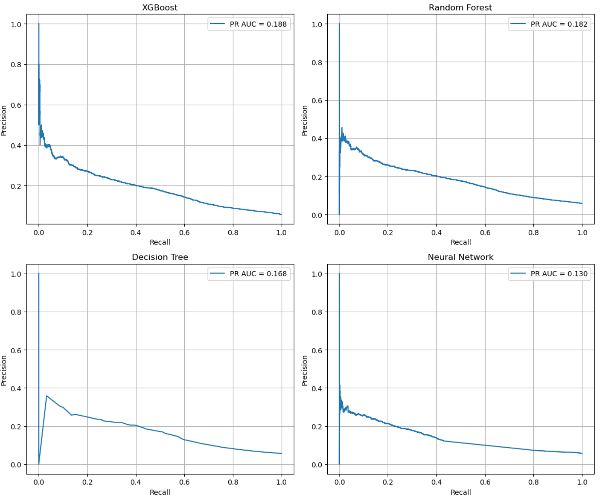

Figure 14. PR AUC of models

In model selection, we prioritised evaluation metrics suitable for imbalanced datasets, as the donor conversion rate is relatively low (approximately 4.4%). While both ROC AUC and PR AUC provide useful indicators of ranking performance, **PR AUC is better suited for this task** because it focuses specifically on the performance of the minority (positive) class. For example, the **XGBoost model achieved a PR AUC of 0.19**, which is notably high given the base conversion rate of 0.044. This suggests that, by using the model's probability estimates, we can improve our ability to correctly identify a true converter by up to **5 times** compared to random guessing. Random Forest followed closely with a PR AUC of 0.182, also demonstrating strong performance.

However, to ensure a fair comparison that balances both **precision and recall**, we conducted **threshold analysis using the macro-averaged F1 score**. A custom function (best_f1) was implemented to iterate through classification thresholds from 0 to 1 in increments of 0.001, computing the macro F1 score at each point. The **macro F1 score** averages the F1 values of both classes equally, regardless of class size, and thus reflects a model’s ability to perform well across both converters and non-converters.

After evaluating models based on their highest macro F1 scores:

* **Random Forest** achieved the best score at **0.6055**
* **XGBoost** followed with **0.6020**
* **Decision Tree** also scored **0.6020**
* **Neural Network** trailed with **0.5819**

Based on this analysis, we selected **Random Forest as the final model**, as it provided the best balanced trade-off between precision and recall across both classes. While XGBoost led in PR AUC, Random Forest offered slightly better classification consistency overall when thresholded for actual decision-making.

This approach ensures that model selection is not only based on probabilistic ranking but also reflects **realistic classification performance**, which is especially important for operational use in prioritising donor outreach.

# 5. Proposal of the strategic project

## 5.1. Key issues identification

* **Unstable income stream**: Funding across the sector is inherently unstable and subject to external influences such as policy changes or economic downturns because of the voluntary nature of giving.
* **Inconsistent revenue from emergency appeals**: Emergency appeals can offer temporary relief but lack consistency, making long-term strategies budgets forecasting difficult.
* **Dependence on single donors**:The majority of the donor base consists of one-off donors, whose contributions are typically event-driven and emotionally motivated. Research indicates that nearly 50% of single-time donors do not return to give again, making it difficult to plan for long-term, sustained efforts (Bagot et al., 2016).
* **Ineffective Outreach Strategy:** Analysis shows that most donor conversions happen early, often after just one or two donations, suggesting that outreach is most effective when concentrated shortly after a donor’s initial engagement. Interestingly, converters tended to make fewer donations prior to converting than non-converters. This may suggest that many non-converters, despite demonstrating strong ongoing engagement, did not receive timely or effective prompts to transition into regular giving. Their extended donation histories, in the absence of targeted follow-up, may indicate a missed opportunity to convert.
* **High fundraising cost and transparency requirements:** Acquiring new donors demands substantial investment in marketing and administrative processes. With low donor retention, these acquisition costs reduce overall fundraising efficiency and divert resources away from direct program delivery. Simultaneously, charities are expected to maintain financial transparency, increasing operational burden (ACNC, 2021)
* **Limited data-driven targeting:** There is considerable room for improvement in using data to more effectively identify and engage supporters who are likely to commit to long-term giving. Moreover, gaps in data quality hinder personalisation efforts, with over 60–90% of records missing key fields such as age, postcode and communication preferences.

## 5.2. Rationale for the Recommendation

The proposed strategy is underpinned by key insights derived from the predictive model, which identified that the majority of donor conversions occur within the first one or two donations. This highlights the importance of engaging donors promptly and strategically during these early interactions. The model also emphasised that recency of donation, frequency of giving and preferred donation channels, particularly credit card and direct mail, are among the strongest predictors of conversion likelihood. In addition, postcode score and the young donor index emerged as influential factors, suggesting that targeting younger donors residing in mid to high postcode score areas could offer improved cost efficiency in conversion campaigns. Failure to engage and convert donors swiftly increases the risk of donor attrition or relegation to irregular giving patterns, thereby forgoing the opportunity to maximise their long-term value and support to the organisation. This reinforces the need for a data-driven, personalised approach that focuses on the critical early stages of the donor lifecycle, ensuring that engagement efforts are both timely and cost-effective.

## 5.3. Strategy Outline

To address the identified gaps in donor conversion, it is recommended that the **organisation modifies its current approach to donor engagement** by introducing data-driven, personalised communication strategies. Leveraging the trained predictive model developed in this project, the charity can enhance its outreach by targeting high-potential one-off donors and offering them more tailored experiences to accelerate their conversion into regular donors.

Specifically, the model has identified that donors with a predicted conversion probability above 70%, who have made only 1-2 donations and donated within the past six months, are most likely to respond positively to targeted campaigns. Furthermore, the model reveals that donors who prefer credit card or direct mail channels demonstrate higher conversion propensities, informing the selection of communication methods.

The proposed strategy involves replacing the existing general outreach tactics with a personalised, data-informed communication flow, which will include:

* Personalised impact narratives, showcasing the tangible outcomes their regular support can deliver.
* Timely engagement nudges within 30 days of the last donation, ensuring the donor remains connected and aware of the opportunity to deepen their impact.
* Streamlined opt-in pathways to regular giving programs, making it easy for donors to convert via their preferred channel, such as credit card or direct mail.

Additionally, a structured implementation roadmap will be followed:

* The predictive model will be deployed to the donor database to generate updated scores.
* Donors will be segmented and prioritised based on these insights for tailored outreach campaigns.
* The campaigns will leverage a multi-channel approach, combining SMS, email, and direct mail communications aligned to the donors’ preferred giving channels.
* An initial pilot campaign will be run over three months, enabling the team to measure conversion uplift, adjust messaging, and scale successful practices.

## 5.4. Model exploitation for strategic outreach strategy

Traditionally, UNICEF has segmented its supporters based on historical donation patterns and engagement levels (UNICEF, 2022). While this retrospective approach provides some insight, it risks misdirecting outreach efforts, as past behaviours are not always reliable indicators of future commitment. To address this, a forward-looking segmentation approach grounded in predictive modelling is proposed.

The model will assign each one-off donor a probability score indicating their likelihood of converting to a regular giver. Donors will then be segmented into three tiers based on these scores:

1. **High potential** (Predicted probability >70%)
2. **Medium potential** (Predicted probability between 40% and 70%
3. **Low potential** (Predicted probability below 40%).

This segmentation allows UNICEF to **prioritise its engagement resources** toward donors with the greatest expected return, enhancing overall efficiency and impact.

For high-potential donors, who are most likely to convert and generate long-term value, the strategy recommends **allocating a significant share of campaign spending toward personalised engagement.** These individuals will receivetailored communications that reflect their donation history and highlight the direct impact of becoming a regular supporter. Messaging may include emotionally resonant narratives, case studies or updates on programs they have previously supported. Furthermore, the mode of communication will also be adapted to suit individual preferences. Where appropriate, **more personal approaches** such as handwritten letters or custom thank-you messages will be used to reinforce the donor’s importance and deepen the relationship.

Medium donors, who exhibit moderate conversion potential, will be targeted through broader yet strategically designed promotions. These may include invitations to trial regular giving programs or time-limited appeals that encourage ongoing support. While the level of personalisation for this group will be more limited, messaging will continue to focus on building familiarity and trust over time.

Low-potential donors, while not currently likely to convert, will remain part of the general communications stream. They will receive standard updates and appeals, ensuring continued engagement **without disproportionate resource allocation**. Importantly, their behaviour will be continuously re-evaluated. As new donation data becomes available, model scores will be updated, allowing for timely reclassification should their likelihood to convert increase due to changes in behaviour or campaign responsiveness.

To evaluate the effectiveness of this strategy, a three-month pilot campaign will be launched, comparing it to their traditional outreach strategy. This test will use two groups to see which one gets better results. Key metrics may include how many people become regular donors, how much it costs to get each donor and how much money each new donor gives over time.

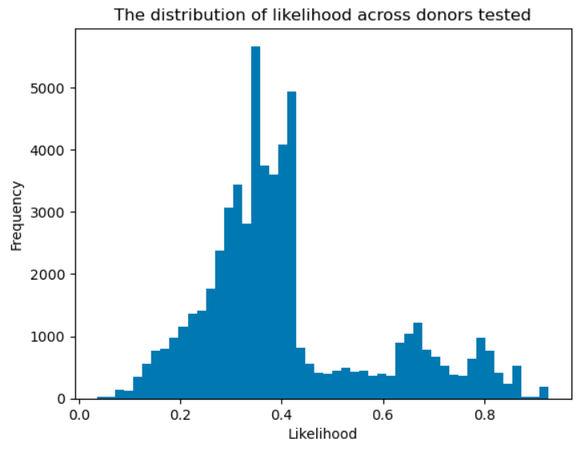

Figure 15. Distribution of likelihood across donors

## 5.5. How the solution addresses the issue identified

As outlined in the key issues identification, this strategy is designed to address five critical challenges currently faced by the charity’s donor engagement and fundraising operations.

Firstly, by modifying the current outreach approach with personalised, data-driven communication strategies, the solution directly **tackles the** **unstable income stream** and reliance on one-off donors. Introducing model-informed donor targeting and personalised engagement journeys will increase the probability of converting one-off donors into regular donors, ensuring a more predictable and stable revenue flow. This approach leverages the charity’s existing donor base more efficiently, reducing its dependence on sporadic emergency campaigns and emotional appeals.

Secondly, creating a structured, automated donor journey including timely nudges, impact storytelling, and low-friction opt-ins **addresses the** **issue of high fundraising costs** and **donor acquisition** inefficiency. By focusing resources on donors identified by the model as most likely to convert, the strategy improves fundraising ROI by reducing wasted efforts on unlikely prospects, thus optimising marketing spend and administrative processes. This efficiency gain enables the charity to redirect funds toward direct program delivery, aligning with sector expectations for transparency and operational accountability (ACNC, 2021).

Thirdly, integrating the predictive model into the CRM system and ongoing campaign management processes will significantly **improve the charity’s limited data-driven targeting capabilities**. This enables the charity to adopt industry best practices in donor lifecycle management, where donor behaviours, preferences, and engagement signals are continuously analysed and acted upon. Over time, this will lead to more precise segmentation, higher conversion rates, and better donor retention strategies, ultimately supporting the charity’s long-term sustainability.

Lastly, by implementing this predictive model-guided conversion strategy, the charity can **reduce its reliance on unpredictable income from emergency appeals**, allowing for better financial forecasting and long-term program planning. The stability gained through increased regular giving will support the charity in committing to multi-year projects with confidence, improving its impact planning and stakeholder credibility.

In summary, the proposed solution addresses the charity’s most pressing challenges by enhancing donor conversion, reducing costs, improving targeting accuracy, and stabilising income streams through data-driven strategies.

## 5.6. Practical Implementation of the Strategy

### 5.6.1. Competition Analysis

Many non-profit organisations and charities currently use generic, mass outreach strategies to engage one-off donors, often relying on broad email campaigns and generic messaging. While this approach may reach a large audience, it lacks the personalisation and targeted approach that is proven to improve donor conversion and engagement rates.

Leading international NGOs such as UNICEF and Save the Children have adopted data-driven donor segmentation and personalised multi-channel engagement, using machine learning models to predict donor behaviours and tailoring communications accordingly (UNICEF Australia, 2024). For instance, UNICEF uses predictive analytics to personalise appeals based on donor history, communication channel preference, and timing of outreach, achieving significantly higher conversion rates and reducing fundraising costs.

To remain competitive and ensure the charity maximises the value of its existing donor base, it is critical to adopt similar advanced approaches. The charity can improve its conversion rates and build sustainable, long-term donor relationships by modifying the current outreach strategies with personalised, model-informed donor journeys.

### 5.6.2. Revenue Estimation

Using the insights from the predictive model and past donor data, an estimation of the potential increase in revenue from implementing the personalised communication strategy was conducted. The campaign targets ~ 5,600 donors predicted by the model to have a conversion probability greater than 70%.

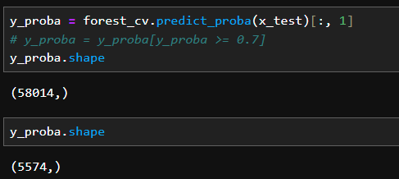

Figure 16. Number of donors having over 70% conversion probability

Using **conservative assumptions**, we project an **8% uplift** in conversion—above the 5% baseline—based on both model inference and literature on personalised donor targeting. Given an average **monthly donation of $25**, the annual revenue per newly converted donor is $300. This results in the following projection:

**Annual Incremental Revenue** = 4,000 donors × 8% uplift × $25 × 12 months  
 = **$96,000**

These figures align with industry reports such as the Dataro (2025), which highlight significant revenue potential when targeting donors with high retention value. Furthermore, prior research from Sargeant (2008) demonstrated that improving retention by just 10% can boost long-term donor value by over 200%, reinforcing the long-term benefit beyond just initial conversion.

The **ROI of the pilot campaign is projected at 19.2x**, calculated as $96,000 in new revenue divided by $5,000 in cost, which will be broken down in the following section. This high return is particularly compelling given the low-risk nature of the intervention and the fact that all resources used (data, channels, CRM) already exist within UNICEF’s operational ecosystem.

### 5.6.3. Cost Estimation

To evaluate the financial feasibility and strategic value of the proposed Conversion Acceleration Program (CAP), we conducted a cost analysis based on model outputs and campaign execution assumptions. The total estimated cost of implementing the pilot campaign is $5,000, broken down into four primary components:

First, data scoring and CRM integration is budgeted at $2,000, reflecting the technical effort required to apply the trained model to the current donor database, score supporters by their likelihood to convert, and export that intelligence into UNICEF’s campaign infrastructure. This estimate assumes 40 hours of labour at a conservative $50/hour, aligning with typical data engineer or CRM consultant rates in the nonprofit sector (Upwork, 2024).

Second, campaign creative production is estimated at $1,500. This cost encompasses the design of tailored assets for three delivery modes: email, SMS, and direct mail. Nonprofit marketing guides (MarketingFaktor, 2025) suggest costs of $500–$1,000 per campaign for messaging and creative asset development. Our estimate sits at the midpoint and ensures capacity for quality, segment-specific messaging, which literature shows can increase conversion rates by up to 30% when personalised (MOAS, 2025; Ghoorah et al., 2025).

Third, campaign execution is projected at approximately $1,000. This includes distribution across digital and physical channels: for 5600 contacts via SMS/email at ~$0.01 per message (standard rates per Twilio, 2025), and 800 premium contacts through direct mail at ~$1.2 each (BlueGrass, 2024). Our blended average cost of ~$0.25 per contact remains conservative and cost-efficient given the expected lifetime value of a converted donor.

Fourth, monitoring and evaluation is budgeted at $500, covering approximately five hours of post-campaign data analysis, uplift measurement, and iterative model refinement. This aligns with rates for digital campaign analysts or fundraising data specialists in the nonprofit space, where such services typically range between $400 and $1,000 (Bonterra, 2022).

Together, these cost components yield a total budget of $5,000, which is lean relative to comparable donor engagement initiatives and made more efficient by leveraging existing CRM and outreach systems. Critically, this projection does not even account for secondary benefits such as reduced acquisition costs, increased donor lifetime value (via upgrades or advocacy), or the potential for automated, scalable deployment. These benefits further strengthen the business case for immediate execution and future expansion of the CAP.

### 5.6.4. Limitations and Assumptions

The recommendations presented in this project are subject to several limitations, primarily related to the dataset size, data quality, and the predictive model’s inherent constraints. Many of the model’s key insights—such as the significance of donation recency, channel preference, and postcode score—are drawn from a historical dataset that may not fully reflect donors' current or future behaviour.

Firstly, the model training and testing datasets exhibited considerable gaps and missing values, particularly in demographic data and donor motivations. While postcode score was used as a proxy for socioeconomic status, this indicator may not fully capture donor intent or loyalty drivers. Additionally, the data only included observable giving behaviours (such as donation frequency and channel), but lacked qualitative data such as donor satisfaction or engagement sentiment, potentially limiting the accuracy of conversion predictions.

Secondly, revenue projections were calculated based on the assumption that donors will maintain regular giving for a continuous 12-month following conversion. In practice, donor behaviour is known to vary, and attrition rates can fluctuate due to various external and personal factors. Thus, the projected incremental revenue may overestimate the financial impact if donor retention does not meet expectations.

Furthermore, the predictive model itself is limited by the data it was trained on, which was heavily skewed towards historical high-frequency donors and lacked diversity in donor age groups and communication preferences. This may have reduced the model’s generalisability across the broader donor base. As such, expanding the data collection scope to include additional variables such as donor age, gender, campaign engagement history, and website visit patterns could significantly enhance the model’s predictive accuracy, supporting more refined segmentation and personalisation.

Finally, the estimated costs of campaign execution were derived from publicly available data on typical communication and mailing expenses, which may not fully reflect potential economies of scale or existing operational efficiencies within the charity’s fundraising team. Therefore, the calculated return on investment should be viewed as a conservative estimate, and actual implementation costs may be lower in practice.

# 6. Conclusion

A key objective of this project was to improve UNICEF Australia’s donor retention by identifying one-off donors most likely to convert into regular givers. By leveraging advanced data analytics and predictive modeling, the team developed a robust strategy grounded in behavioural patterns, communication preferences, and socio-demographic characteristics. The analysis revealed that factors such as donation recency, frequency, and preferred giving channels—particularly credit card and direct mail—are strong predictors of conversion. These insights informed a data-driven outreach strategy designed to engage supporters during their most responsive windows, thereby stabilising long-term revenue and strengthening UNICEF’s financial resilience.

The second objective was to build an effective predictive model capable of supporting strategic decision-making. Despite challenges such as class imbalance, missing demographic data, and highly skewed donation distributions, the final model—Random Forest—achieved a strong balance of precision and recall. Notably, the feature engineering process introduced novel metrics such as R_mean (average donation interval) and Contactability Index, which captured nuanced patterns in supporter behaviour. The successful integration of these variables not only enhanced model accuracy but also highlighted key intervention points that UNICEF can act upon to increase donor lifetime value.

Ultimately, this project demonstrates how data science can be harnessed to address real-world fundraising challenges in the nonprofit sector. The proposed strategy offers UNICEF a scalable and cost-effective framework for improving donor conversion, backed by measurable uplift projections and supported by a structured implementation roadmap. As the organisation continues to adapt to an increasingly digital donor landscape, the insights and tools developed here provide a sustainable feedback loop to drive engagement, optimise campaign resources, and deepen long-term supporter relationships—helping UNICEF advance its mission more effectively.

# 7. References

Andreoni, J. (2006). Philanthropy. *Handbook of giving, reciprocity and altruism*, *1*, 341-369

Australian Charities and Not-for-profits Commission. (2021, September 1). Australian Charities and Not-for-profits Commission Act 2012. Www.legislation.gov.au; scheme=AGLSTERMS.AglsAgent; corporateName=Office Parliamentary Counsel; address=Locked Bag 30 Kingston ACT 2604; contact=+61 2 6120 1400. https://www.legislation.gov.au/C2012A00168/latest/text

Bagot, K. L., Murray, A. L., & Masser, B. M. (2016). How Can We Improve Retention of the First-Time Donor? A Systematic Review of the Current Evidence. Transfusion Medicine Reviews, 30(2), 81–91. https://doi.org/10.1016/j.tmrv.2016.02.002

Barber, P., & Levis, B. (2013). *Donor retention matters*.<https://www.urban.org/sites/default/files/publication/23231/412731-Donor-Retention-Matters.PDF>

‌Bennett, R. (2003)*.* Factors underlying the adoption of charity marketing*. International Journal of Nonprofit and Voluntary Sector Marketing, 8(4), 316-334*

Bluegrass. (2024). *Direct Mail Marketing Cost.* We Are Bluegrass. https://wearebluegrass.com/blog/direct-mail-marketing-cost/

Bonterra. (2025). *Fundraising and Engagement Pricing*. Bonterra. https://www.bonterratech.com/pricing/fundraising-and-engagement

Breiman, L. (2001). Random Forests. *Machine Learning*, *45*(1), 5–32.<https://doi.org/10.1023/a:1010933404324>

Dataro. (2025). *How to Improve Donor Retention: Data Insights, Trends & Strategies for Nonprofits*. Dataro.io. https://www.dataro.io/blog/how-to-improve-donor-retention-data-insights-trends-strategies-for-nonprofits

Ghoorah, U., Mariyani-Squire, E., & Zoha Amin, S. (2025). Relationships between financial transparency, trust, and performance: an examination of donors’ perceptions. *Humanities and Social Sciences Communications*, *12*(1). https://doi.org/10.1057/s41599-025-04640-2

‌Guerrini, V. (2025, May 6). *Donor retention in nonprofit fundraising | Altrata*. Altrata. https://altrata.com/articles/donor-retention-in-nonprofit-fundraising

Marketing Faktor. (2025).  *Fundraising costs: What does a fundraising campaign cost.* Marketing-Faktor. https://www.marketing-faktor.de/en/fundraising-costs/

MOAS. (2025). *Did you know that 93% of nonprofits now conduct online fundraising campaigns? As digital tools reshape fundraising, nonprofits must adapt to thrive in a digital-first world. Fundraising is the backbone of nonprofit organisations, enabling us to drive meaningful change and support critical missions.* Linkedin.com.<https://www.linkedin.com/pulse/5-digital-tools-transform-your-nonprofits-v6l1c/>

Räz, T. (2024). ML interpretability: Simple isn’t easy. *Studies in History and Philosophy of Science*, *103*, 159–167.<https://doi.org/10.1016/j.shpsa.2023.12.007>

Ribeiro, J., Santos, R., Analide, C., & Silva, F. (2024). Exploring Transparency in Decisions of Artificial Neural Networks for Regression. *Lecture Notes in Networks and Systems*, 347–356.<https://doi.org/10.1007/978-3-031-60221-4_34>

Rolle, D. M. (2023). *Nonprofit Administrator Strategies to Procure and Retain Long-Term Donors*. ScholarWorks. https://scholarworks.waldenu.edu/dissertations/13095/

Sargeant, A., & Hartsook, R. (2008). *Donor Retention: What Do We Know and What Can We Do About It?* https://charitablegiftplanners.org/sites/default/files/sargeant-donor-retention-what-do-we-know-and-what-can-we-do-about-it.pdf

UNICEF. (2022). *UNICEF Resource Mobilization Strategy : 2022-2025*.

UpWork. (2025). *Hire the best CRM Developers*.<https://www.upwork.com/hire/crm-consultants/>